Name:
Adam Fraeyman
Group:
9A - 2
Basic Science Question:
How does healing occur following extraction?
Report:
After a tooth extraction, there is a period of wound healing. As a normal biological process in the human body, this healing is achieved through four highly programmed phases: hemostasis, inflammation, proliferation, and remodeling.
These phases are overlapping as there is not a clear cut start and end to each phase before the next begins, but rather a chain of events. Many variables can alter one stage or many stages of this pathway, thus causing improper tissue repair; factors such as pocket depth, size of tooth extracted, and patient medical history. It is important to note that the bone structure will take longer to heal than the surrounding gingiva.
The first step of wound healing is hemostasis and begins immediately after the tooth is removed as evidenced by the bleeding that occurs on site. This vascular constriction causes the release of inflammatory cytokines and growth factors which ultimately leads to blood clot formation After the clot has formed and bleeding is controlled, inflammatory cells migrate into the wound to begin phase 2, or the inflammation phase.
This second phase can be seen by the inflamed or tender gingiva around the extraction site and is due to the rapid influx of neutrophils, macrophages, and lymphocytes to the extraction site. Together, these biomolecules remove cellular debris from the area, clearing apoptotic cells, and ultimately promote the transition to the proliferative phase of healing.
The third phase of proliferation typically overlaps the inflammatory phase since you can’t have one process without the other. Fibroblasts and endothelial cells are most important in this step in order to rebuild collagen and reform granulation at the site of the extraction in order to rebuild a strong extracellular matrix.
The fourth and final phase is the remodeling phase which ultimately can last for many years. This stage uses the recently reformed ECM to provide vasculation to the tissue again, reduce swelling and attempt to regain normal function of the area again by reforming the collagen.
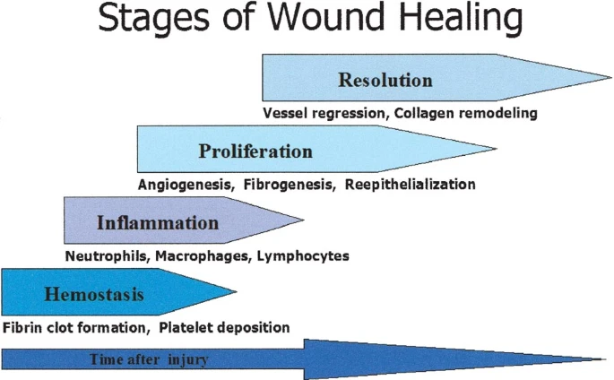

References:
- Adeyemo, Wasiu Lanre, et al. “Clinical Evaluation of Post-Extraction Site Wound Healing.” The Journal of Contemporary Dental Practice, vol. 7, no. 3, 1 July 2006, pp. 40–49., doi:10.5005/jcdp-7-3-40.
- Gosain, Ankush, and Luisa A. Dipietro. “Aging and Wound Healing.” World Journal of Surgery, vol. 28, no. 3, 2004, pp. 321–326., doi:10.1007/s00268-003-7397-6.
- Guo, S., and L.a. Dipietro. “Factors Affecting Wound Healing.” Journal of Dental Research, vol. 89, no. 3, 2010, pp. 219–229., doi:10.1177/0022034509359125.
- Sutera, Charles. www.aestheticsmilereconstruction.com/2020/06/02/how-long-does-it-take-the-hole-to-close-after-a-tooth-extraction/.
- “Tooth Extraction Healing Pictures.” Animated-Teeth.com, 17 Oct. 2019, www.animated-teeth.com/tooth_extractions/a-tooth-extraction-healing-times.htm.

