Student Name:
Nisha Soni
Case abstract (Provide a brief synopsis of this patient):
38 year old patient
Female
Caucasian
CC: Throbbing pain in upper right
axiUm Chart:
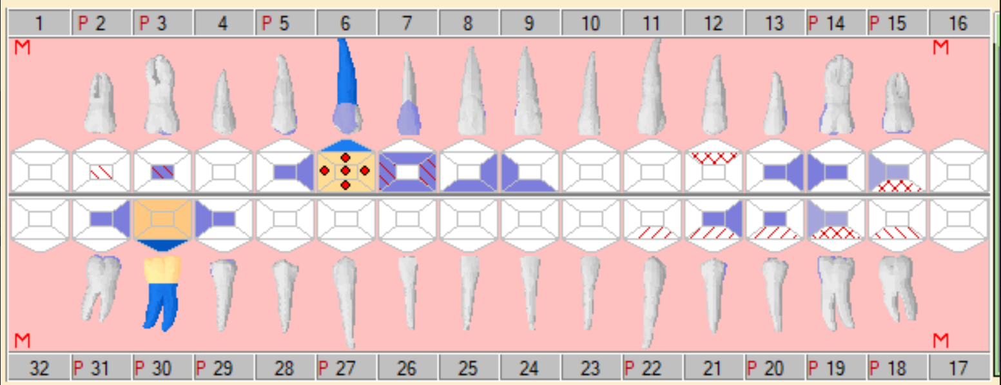
Date of Rounds presentation:
9/23/2020
D3 Student:
Macy Lentz
D2 Student:
Christian May
D1 Student:
Matthew Johnson
Medical History:
- Latex allergy
- History of cold sore flare-ups
- Medications: Depo-provera (birth control)
- Current smoker

Dental History:
- Regular prophies, restorative fillings, root canal therapy
- Sensitivity to hot and cold
- Oral hygiene:
  - Brushes 2x/day
  - Floss 1x/week
  - Experiences bleeding
- Unhappy with
  - Chip on #12
  - Length difference between #8 and #9
  - Gap between #26 and #27

Radiographic Findings:
PARL on #6
Clinical Findings:
Defective restorations on occlusal surfaces of molars
Periodontal Findings:
Gingval health with PD of 1-5
Periodontal Diagnosis:
Stage 2 Class B
Problem List:
- Sensitivity and pain
- Caries
- Bleeding
- Aesthetics

Other:
Click here to enter text.

