Name:
Sarah Doughty
Group:
3A-2
Basic Science Question:
- What is the difference between a porcelain fused to metal restoration compared to layered Zirconia restoration?

Report:
Porcelain fused to metal (PFM) restorations have been used in dentistry for a longer time than layered zirconia restorations. Consequently, studies involving layered zirconia are generally much shorter and less is known about the long term effects of them. A systemic review of the survival of these two types of restorations determined that the estimated 5-year survival rates of a single zirconia crown and a PFM restoration were 92.1% and 94.7%, respectively, indicating no significant difference between the two restorations (Sailer et al., 2015).

Zirconia is made from zirconium dioxide and yttrium, which is added to stabilize the zirconia crystals in a tetragonal structure. This ultimately creates a material with strong mechanical, thermal, and electrical properties, which is also stronger and more resistant to wear than porcelain (Anusavice et al., 2013). Zirconia can be layered either through conventional layering or facial layering. Facial layering is the stronger of the two because only the facial surface is layered for a better esthetic result than a monolithic design. Overall, layering causes more fractures than monolithic zirconia preparations, but has excellent esthetic outcomes for the anterior teeth. PFM restorations involve placing a porcelain veneer on top of a metal substructure which provides a strong foundation along with proper esthetics. The layers from cervival to incisal are a metal substructure (metal coping), an oxide layer that forms from the metal, opaque porcelain, body porcelain, incisal porcelain, and transparent porcelain as shown in the figure below (Anusavice et al., 2013).
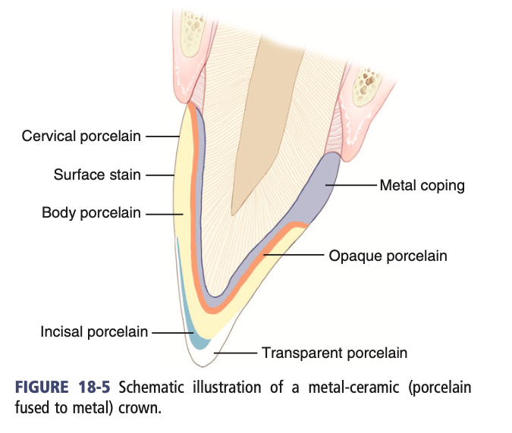

Both type of restorations have strengths and weaknesses. While zirconia has better esthetic outcomes when layered and provides better control of the translucency and opacity of the restoration, it may wear down the opposing enamel (abrasion). In comparison to PFM restorations, Zirconia restorations are less likely to be overcontoured because PFM restorations require a layer large enough on top of the metal coping to prevent breakage. PFM restorations also require a more extensive preparation to provide space for the multiple layers shown in the figure above but ultimately are highly resistant to fracture. Another potential weakness of PFM restorations is the potential for patients to be allergic to the metal component (Anusavice et al., 2013).

References:
Sailer, Irena et al. “All-ceramic or metal-ceramic tooth-supported fixed dental prostheses (FDPs) A systematic review of the survival and complication rates. Part I: Single crowns (SCs).” Dental materials : official publication of the Academy of Dental Materials vol. 31,6 (2015): 603-23. doi:10.1016/j.dental.2015.02.011

Anusavice, Kenneth, Chiayi Shen, and Ralph Rawls. Phillips’ Science of Dental Materials. Saunders, 2013

