Student Name:
Tia Rinzel
Case abstract (Provide a brief synopsis of this patient):
Patient is a 14 yr/o female. Her behavior presents as a challenge in the operatory, with frequent disruption, foul language and attention deficiency. In October 2019 she presented in the pediatric department with an avulsed #9 and #10 due to getting in a fight with cousin. She had previously been to the Emergency Room where they replanted and splinted teeth. Splint fell out and new splint was made from stainless steel was placed on facial of #7-12. After 2 weeks of wearing the splint it was removed. The first week in November, 2019 she presented in Endo department for initiation of RCT on #9, #10. Accessed #9 and cleaned/shaped and placed calcium hydroxide. Same was done for #10 in December 2019. In February 2020 completion of RCT on #9. In September 2020, there was 20% root resoprtion shown on # 10 and both teeth showed Class I mobility, however completion of RCT #10 was done.
axiUm Chart:
P680650
Date of Rounds presentation:
Oct 7^{th,} 2020
D3 Student:
Matthew Mueller
D2 Student:
Chloe Philip
D1 Student:
Aman Goyal
Medical History:
According to mother, patient is not on any medications or allergies. Patient has behavioral issues. She lives at Milwaukee Behavioral Center.
Dental History:
Presented to in me in pediatrics in September 2019 for POE and prophy. Incipiant caries present on D #2, L #3, M/D #4, ,L #14, L #15, B #18 , and B #19 Patient had a chip on incisal #8 and wanted it fixed. Patient had from previous visits sealants planned on 1st and 2nd molars in each quadrant. She also had buccal pit restorations on #18 and #31.
Radiographic Findings:
-10 percent root resorption on #9
-20 percent root resorption on #10

Detected as of Sept 2020
Clinical Findings:
Oct 2019:

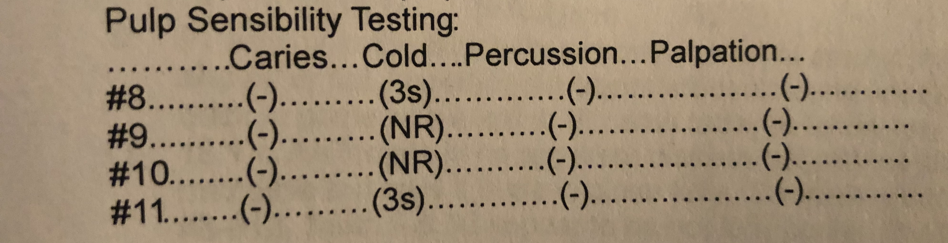

Sept 2020:
Grade 1 mobility on #9, #10
No swelling or pain on percussion
Periodontal Findings:
Pocket depths around #10 were 3,1,3 for facial and 3, 1, 2 for lingual
Periodontal Diagnosis:
Diagnosis of teeth after pulpal sensibility testing:
-pulpal necrosis with asymptomatic apical periodontitis subsequent to trauma.
Problem List:
Root resorption, mobility, misalignment of teeth
Other:
Click here to enter text.

