MUSoD Rounds
D4 Case Information

Student Name:
Nadia Hatoum
Case abstract (Provide a brief synopsis of this patient):​
Patient is a 38 year old female who works in construction. She presented to MUSoD with generalized gross decay (most teeth at the gum line). Her chief complaint was “I have to be able to chew”. She indicated that she knew her teeth were bad and she wished to replace her dentition with implants. The patient had a strong disdain for any sort of removable appliance and indicated due to her age she felt she should not be wearing dentures.
axiUm Chart:
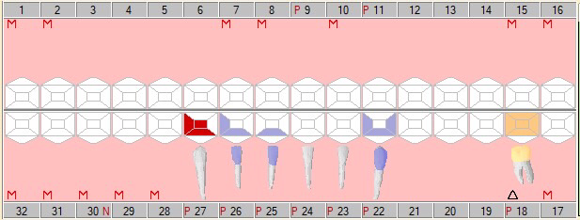
Date of Rounds presentation:
October 7, 2020
D3 Student:
Lucas Schwartz
D2 Student:
Nikhila Alsakani
D1 Student:
Matthew Kettering
Medical History:
Medications:
- Carisoprodol
- Adderal (not taking anymore)
Allergies
- Penicillin
Medical History:
- Past smoker, current vaper (2 cartridges a day)
- History of cervical cancer in 2002
- Headaches and migraines
- ADD/ADHD
- History of ulcers
- History of gallbladder stones
Dental History:
Dental procedures:
- Extractions
- Root Canal Therapy
- Flipper
- Bridges
Dental Problems:
- Dental pain
- Sensitivity to sweets and pressure
- Trouble chewing
- Headaches
- Gross decay
- Primary caries
- Unhappiness with appearance of teeth and smile
Radiographic Findings:
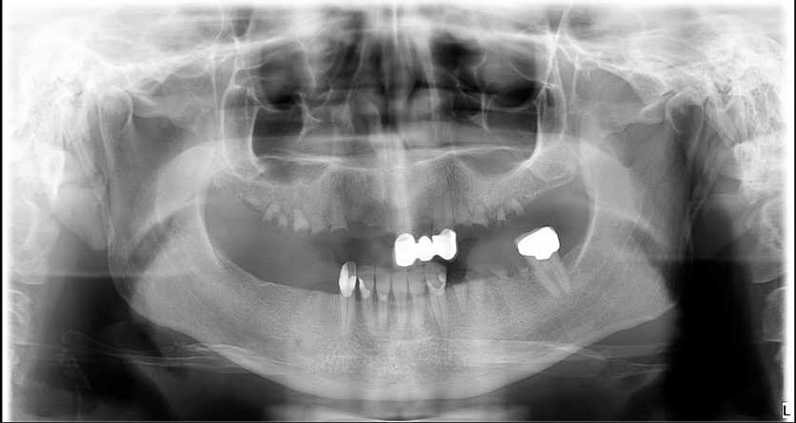

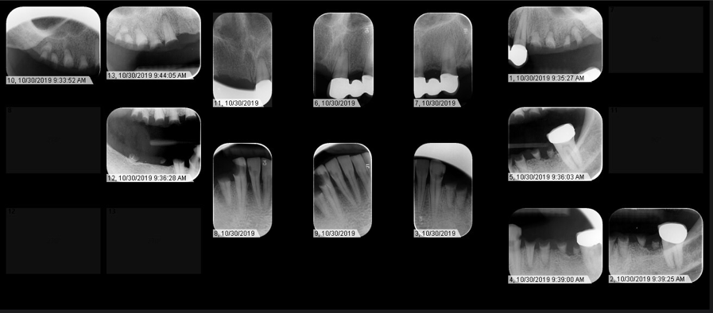

Radiographic Bone height from CEJ:
- Upper right: no teeth
- Upper anterior: >4mm
- Upper left: no teeth
- Lower right: 2-4 mm
- Lower anterior: >4mm
- Lower left: no teeth
Clinical Findings:
Gross decay:
- 3,4,5,6, 12, 13, 14, 19, 20, 21, 22, 27, 28, 29, 30
Primary Caries:
- 26 DF
- 25 F
Recurrent Caries:
- 11 M
Current restorations:
- FPD 9-11
- ACC 18
Endo treated teeth:
- #30 (evident from remaining root tip)
Functional Evaluation:
- Overbite: 67% (5mm)
- Overjet: 2mm
- Space loss: all posterior teeth missing or grossly decayed. Right upper anteriors missing.
Soft Tissue Evaluation:
- 37 year old Caucasian female WNL
Periodontal Findings:
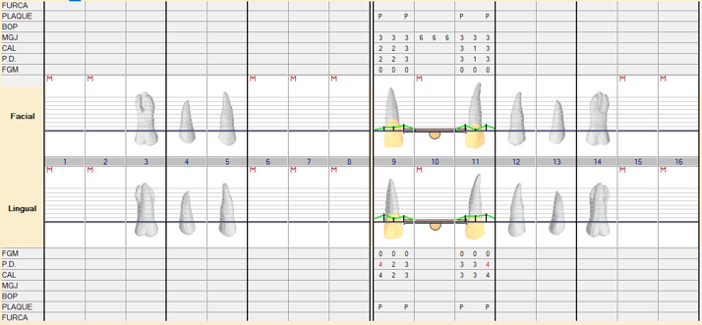

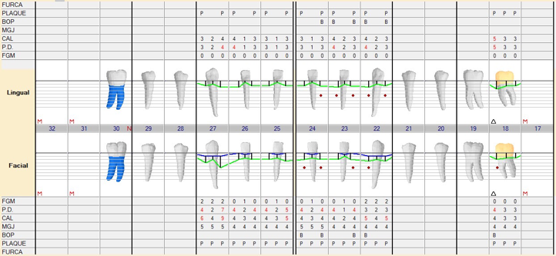

Oral Hygiene Status:
- Plaque: heavy
- Subgingival Calculus: moderate
- Supragingival calculus: moderate

Gingival Description:
- Marginal shape: enlarged (generalized) and rolled (22 and 23 F)
- Color: Pink, Red (around grossly decayed teeth)
- Attached zone: WNL
- Papillary shape: bulbous (generalized); blunted (generalized)
- Consistency: edematous (generalized); spongy (generalized)
Periodontal Diagnosis:
AAP Perio Class:

Moderate chronic periodontitis- generalized
Periodontal instability
Precursor perio risk score (from 1-5): 5
Problem List:
Very High caries risk
Gross decay
Bone loss
Primary caries
Periodontitis
Dental pain
Unhappiness with smile

Other:
