Name:
Hanfrey Deng
Group:
6B-4
Pathology Question:
What is peri-implantitis?
Report:
Dental implants are a very common restoration for patients who are partially or fully edentulous. However, some patients may require a bone graft if they do not have sufficient bone height, before undergoing the surgical insertion of the post & abutment for the dental implant. Typically, healing time & osseointegration takes place over the course of several months.

In order to ensure a successful outcome for dental implants, it is recommended that patients properly control the risk factors for peri-implantitis, such as periodontal disease, diabetes, smoking, and poor oral hygiene habits. For this reason, it is imperative to note baseline radiographic bone levels in order to monitor patients’ bone levels following implant placement.

Typically, healthy gingiva surrounding dental implants lack inflammation (erythema & swelling) & does not bleed upon probing. However, similar to the ability of accumulated biofilm to cause gingivitis & eventual periodontitis, accumulated biofilm can also cause peri-implant mucositis & eventual peri-implantitis. The American Academy of Periodontology defines peri-implant mucositis as “a disease in which the presence of inflammation is confined to the soft tissues surrounding a dental implant with no signs of loss of supporting bone following initial bone remodeling during healing.” The Academy also defines peri-implantitis as “an inflammatory process around an implant, which includes both soft tissue inflammation and progressive loss of supporting bone beyond biological bone remodeling.”

Clinically, peri-implant mucositis demonstrates inflammation & bleeding upon probing, with no abnormal bone loss. Similarly, peri-implantitis demonstrates the same inflammatory & bleeding signs, but with the addition of reducing bone levels. Normally, natural teeth possess supracrestal gingival fibers that form a “protective connective tissue capsule” that separates inflammation from the alveolar bone. However, dental implants lack this protective structure, which may explain the increased susceptibility to bone loss following dental implant placement.

It has been shown that peri-implant mucositis is reversible with proper oral hygiene & non-surgical periodontal procedures. However, upon progression to peri-implantitis, surgical periodontal intervention is indicated to prevent implant failure.

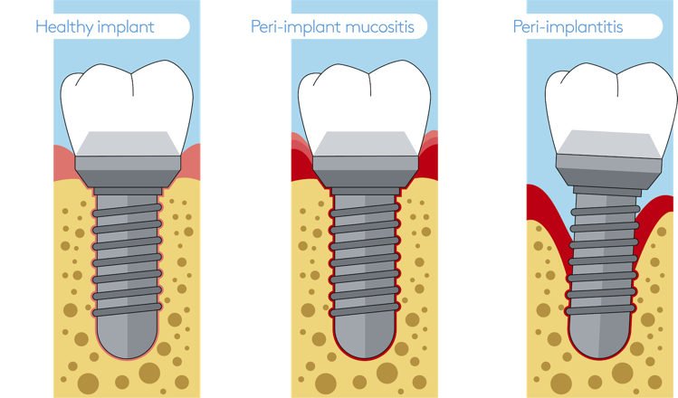

References:
1. Rosen. 2013. Academy Report: Peri‐Implant Mucositis and Peri‐Implantitis: A Current Understanding of Their Diagnoses and Clinical Implications. Journal of Periodontology. 84(4):436-443

2. Peri-Implant Diseases. European Federation of Periodontology [Internet]. [Cited 2020, Oct 11]. Available from https://www.efp.org/dental-implants/peri-implant-diseases/
3. Peri-Implant Diseases. American Academy of Periodontology [Internet]. [Cited 2020, Oct 11]. Available from https://www.perio.org/consumer/peri-implant-disease

