Student Name:
Xavier Goode
Case abstract (Provide a brief synopsis of this patient):
Pt presented to Marquette for comprehensive dental tx. Pt showed up to the comprehensive exam with gross decay on sites #4, 20, 21 in conjuction with endentulous posterior left and right teeth. Notable Decay is also found on mandibular anterior teeth. Pt was informed of which teeth were non-restorable and a mandibular partial was made for the partial edentuate spaces. After the remaining dentition was analyzed #7 space was a concern for the patient. Being that the patient had exhisting PFM’s in the maxillary dentition, it was elected to deliver a PFM bridge that spanned from #6-8, however, the patients high smile line is an esthetic consideration that must be taken into account. When tx planning for the most esthetic outcome, an implant vs. bridge were considered. Due to pt finances and timeline, we elected for the bridge. More research needs to be done to further analyze the benefits of the more estethic prosth modality for replacing maxillary anterior teeth with a high smile line and bony resoprtion.
axiUm Chart:
762452
Date of Rounds presentation:
11/18/20
D3 Student:
Matthew Ang
D2 Student:
Sundeep Khahra
D1 Student:
Ryan Swenson
Medical History:
Latex allegery, high cholesterol, High blood pressure, hx of stent placement in 2000, kidney stones in 2015
Dental History:
Non-frequent dental visits more than 1-2 years since last visit
Pt brushes once a day and sometimes flosses
Mandibular partial
Maxillary bridge #11-13,
Defective crown margin lingual of #10 done by Aspen dental.
Radiographic Findings:
Bilateral mandibular Tori, Residual ridge resportion #7 site (1/29 radiographs)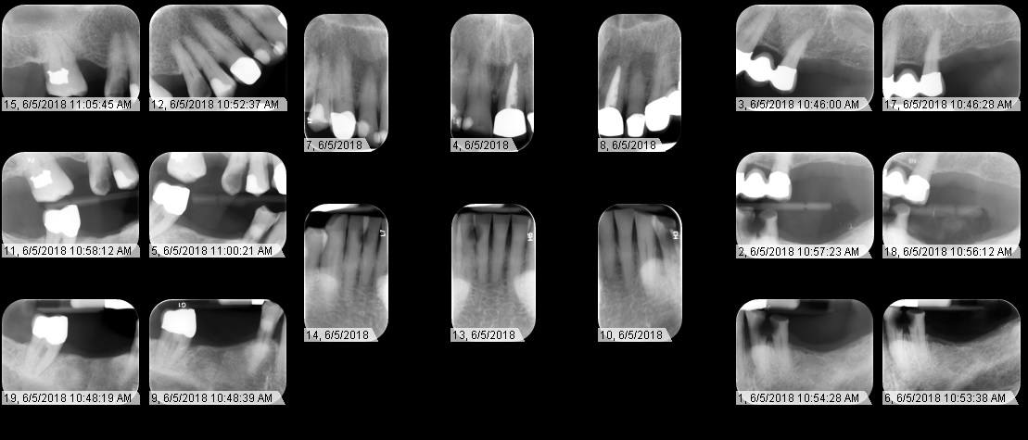
Clinical Findings:
#2 B Amalagam, #5 DO resin, #6 PFM, #8 DL resin, #9 PFM, #10 PFM, #11-13 PFM bridge, Attrition #22,23,24,27, #27 D resin, #31 PFM and grade II furcation
Periodontal Findings:
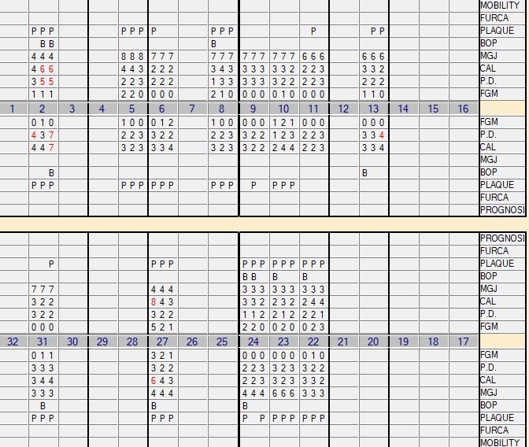
Periodontal Diagnosis:
Chronic periodontitis ADA III
Problem List:
Caries, home care
Other:
N/A

