Critically Appraised Topic (CAT)
Project Team:
4B-4
Project Team Participants:
Furquan, Zoe, Payton, Ana
Clinical Question:
How does the longevity of a PFM crown compare to a FCC or ACC?
PICO Format:
P:
Patient needing post crown
I:
FCC
C:
PFM
O:
Longevity
PICO Formatted Question:
Among patients needing Posterior Crowns, do PFM crowns, as opposed to FCC crowns, offer longer longevity?
Clinical Bottom Line:
The clinical bottom line, unsurprisingly, is that FCC s offer superior longevity when compared to both all ceramic and porcelain fused to metal crowns. However, PFM crowns do offer reliable and long lasting treatment to patients and ACC crowns can serve as a good alternative to PFM and FCC when esthetics are a concern
Date(s) of Search:
10/28/20, 11/8/20
Database(s) Used:
PubMed
Search Strategy/Keywords:
PFM, ACC, full cast crown, longevity, posterior
MESH terms used:
Crowns / adverse effects, Dental Porcelain / therapeutic use, Dental Prosthesis Design, Dental Restoration Failure, Gold / therapeutic use, Treatment Outcome, Zirconium / therapeutic use
Article(s) Cited:
N. Passia, S. Sampf. & J.R. Strub (2013). Five-year results of a prospective randomised controlled clinical trial of posterior computer-aided design-computer-aided manufacturing ZrSiO4 -ceramic crowns Journal of Oral Rehabilitation pp 609-617. https://pubmed.ncbi.nlm.nih.gov/23745725/

Monaco, C., Llukacey, A., Baldissara, P., Arean, A., Scotti, R. (2017). Zirconia-based versus metal-based single crowns veneered with overpressing ceramic for restoration of posterior endodontically treated teeth: 5-year results of a randomized controlled clinical study. https://0-pubmed-ncbi-nlm-nih-gov.libus.csd.mu.edu/28736293/

Canadian Agency for Drugs and Technologies in Health(2015) Porcelain-Fused-to-Metal Crowns versus All-ceramic Crowns: A Review of the Clinical and Cost-Effectiveness
https://www.ncbi.nlm.nih.gov/books/NBK304697/

Study Design(s):
RCT, systemtatic review, and meta analysis
Reason for Article Selection:
High levels of evidence and relevant to PICO
Article(s) Synopsis:
- Five-year results of prospective RCT
This research reviewed 123 ceramic crowns and 100 gold crowns over a 5yr period. At six months, the all ceramic crown survival probability was 98.3% but fell to 73.2% by 5 yrs. Conversely, at six months the gold survival probability was 99% and only fell to 92.3% by 5 yrs. Failure was defined in this study by presence of fracture, caries, need for EXT, and tooth loss. Gold crown failure was mostly due to the need for EXT or caries whereas ceramic crown failure was mostly due to fracture of the crown. [next slide]

Below you can see some of the data from this study. The figure on your left compares the gold crowns on your left and ceramic crowns on your right. The y-axis enumerates the probability of NOT having one of these events occur. As stated previously, as time goes on, we see that ceramic crowns are more likely to fracture as the leading cause of failure, with caries and EXT next. In gold crows we see here a much lower probability of failure over time with EXT being the most probable reason for failure. The second figure here on the right shows survival probability and again we see gold outperforming ACC. [next slide]

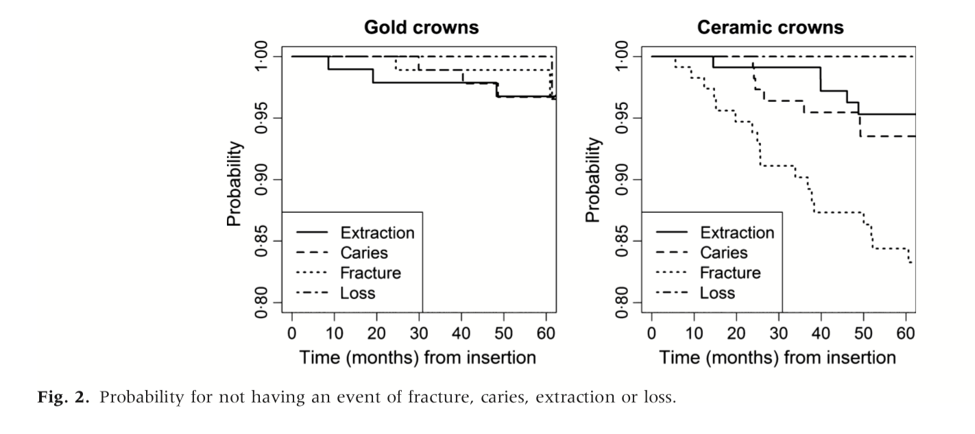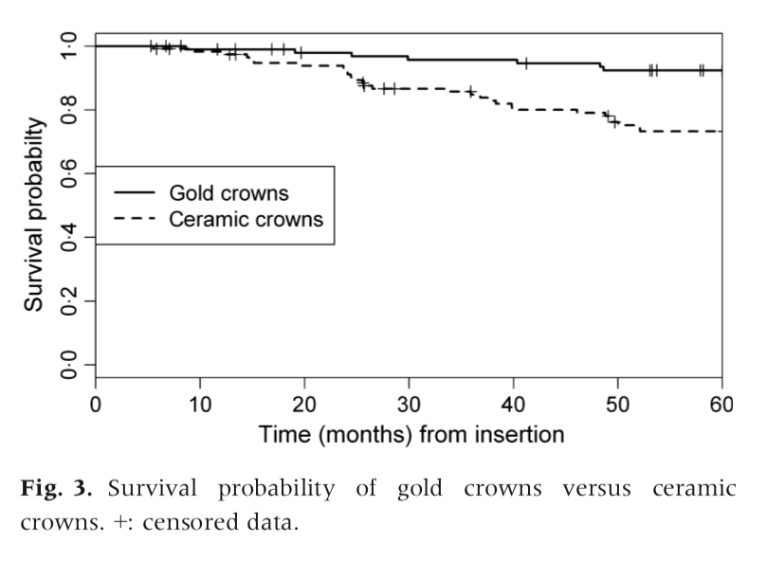

The reason I selected this article was because it was a high level of evidence and was relevant to the PICO question. [next slide]

The level of evidence for this study is 1b because it is an individual RCT and it is confident, good quality patient oriented evidence. [next slide]

My second article is titled “Porcelain-fused to metal crowns versus all ceramic crowns: a review of the clinical and cost effectiveness” and is from the Canadian Agency for Frusga dn Technologies in Health. It was published in 2015 and is a meta analysis. [next slide]
Canadian Agency for Drugs and Technologies in Health(2015) Porcelain-Fused-to-Metal Crowns versus All-ceramic Crowns: A Review of the Clinical and Cost-Effectiveness
https://www.ncbi.nlm.nih.gov/books/NBK304697/

This article compiled data from various systematic reviews and provided date in the short term, mid term, and long term survival. Short term survival, which is less than 5 years, was cited 95.6% for zirconia based crowns and 95.4% for PFM crowns in one study and 92% for all ceramic and 93% for PFM in another. At midterm survival, PFM crowns were cited at 96% whereas all ceramic crowns varied from 83.4% to 96.6% depending on the specific material type. In another study, PFMs came in at 76% and all ceramic crowns at 68%. For long term survival, which is 10+ year, PFM crowns were cited qt 62% survival and all ceramic at 48%. [next slide]

The reason I selected this article is that it was a good level of evidence and gave a long term analysis of the crowns and i was relevant to PICO. If you happen to choose this article for classification, you will notice some of the limitations of the article, but it was great to find something that had data on the crowns after 10 years. [next slide]

As stated, this was a meta analysis so it is a 1a on the EBD pyramid and it is consistent, good quality patient oriented evidence. [next slide]

My third article is from the Journal of Dentistry and was published in 2017. It is a randomized control trial. [next slide]

This article studied survival of zirconia and metal based crowns over a 5yr period. This study specifically looked at crowns that were on endodontically treated posterior teeth. 90 crowns were studies in 72 patients and it was foind that the 5yr survival of the zirconia crown was similar to metal based with no statistically significant differences detected. [next slide]

Here I just included how the researchers divided up the groups. They began with over 150 crowns, but after checking for eligibility criteria, only 90 were left. By the end of the study, 5 of the metal based crown group dropped out, so the final count was 40 metal based and 45 zirconia. [next slide]

The reason I selected this article was because it was a high level of evidence and gave a perspective on endo treated teeth. Endo treated teeth should almost always be crowned, so I thought it was important to note any difference in longevity when endo is involved. And it was relevant to the PICO questions. [next slide]

This was a individual randomized control trial so is 1b on the EBD pyramid and it was consistent, good quality patient oriented evidence. [next slide]

Monaco, C., Llukacey, A., Baldissara, P., Arean, A., Scotti, R. (2017). Zirconia-based versus metal-based single crowns veneered with overpressing ceramic for restoration of posterior endodontically treated teeth: 5-year results of a randomized controlled clinical study. https://0-pubmed-ncbi-nlm-nih-gov.libus.csd.mu.edu/28736293/

Levels of Evidence: (For Therapy/Prevention, Etiology/Harm)
See http://www.cebm.net/index.aspx?o=1025
☒ 1a – Clinical Practice Guideline, Meta-Analysis, Systematic Review of Randomized Control Trials (RCTs)
☒ 1b – Individual RCT
☐ 2a – Systematic Review of Cohort Studies
☐ 2b – Individual Cohort Study
☐ 3 – Cross-sectional Studies, Ecologic Studies, “Outcomes” Research
☐ 4a – Systematic Review of Case Control Studies
☐ 4b – Individual Case Control Study
☐ 5 – Case Series, Case Reports
☐ 6 – Expert Opinion without explicit critical appraisal, Narrative Review
☐ 7 – Animal Research
☐ 8 – In Vitro Research
Strength of Recommendation Taxonomy (SORT) For Guidelines and Systematic Reviews
See article J Evid Base Dent Pract 2007;147-150
☒ A – Consistent, good quality patient oriented evidence
☐ B – Inconsistent or limited quality patient oriented evidence
☐ C – Consensus, disease oriented evidence, usual practice, expert opinion, or case series for studies of diagnosis, treatment, prevention, or screening

Conclusion(s):
If longevity is determined to be the most important factor and highest priority for the patient, then I would recommend treatment using full cast crowns to the D4. Full cast crowns offer the best and most reliable longevity, far outmatching PFM and ACC. PFM and ACC were shown to have similar longevity, with PFM showing slightly more reliable longevity than ACC.
In conclusion, as the data that I’ve discussed showed, PFM and ACC crowns can offer similar longevity but both do not survive as long as a full cast crown. However, if the patient values esthetics, PFM and ACC crowns offer similar longevity and can last a good amount of time, with the highest risk being fracture of the ceramic. Because ACC is more esthetic than PFM and tends to be cheaper, that is another factor to take into consideration when discussing treatment plans with our patients. And as mentioned, there is the risk of contact dermatitis with metal based crowns which is eliminated with ACC. Further research should be done on the specific type of ACC utilized because there are many options out on the market and some studies did show shorter longevity with ACC crowns when compared to PFM crowns.

